ES 319: Environmental Film

Professor: Salma Monani
Class Meeting Times: T 1:10-3:40pm. Film Screening: M 6:30-9:00pm
Classroom: Science Center 152, Screening: SC 200
Office hours: Thursday 2-3:30 pm and by appointment. Office: Science Center 154G
Email address: smonani@gettysburg.edu Office Phone: 337-6269

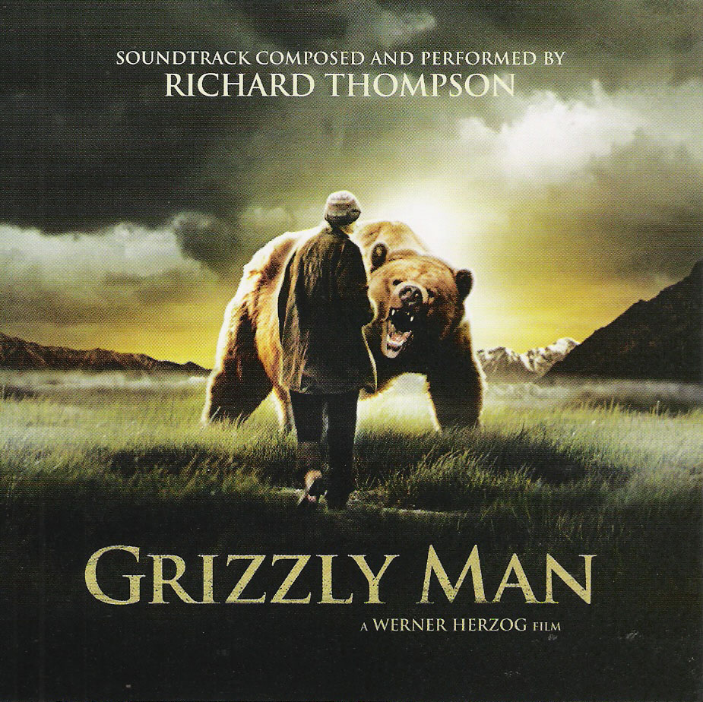
Course overview:

At the dawn of the twentieth century, film, as a medium of expression that documented moving images, was a nascent and novel concept. Today, a century later, its success is all around us, evident in movie theatres and in the more personal spaces of our homes—on our televisions and our computers. What role do films play in shaping our imagination of the environment? How might they influence our actions? These are the central questions we will explore in this class.

Throughout the semester, we will engage in textual and contextual analysis of a variety of films. By the end of semester, through critical analysis of a variety of films throughout the semester you should have a good grasp of films as expressions of environmental discourse and their potential as inspiration and instigators of environmental action.

The class is organized into three parts:

Part I: Foundations
We will begin our exploration by first considering the broad question “why film?” What role does film play in environmental issues, and why give them any attention? Recognizing the role of film in environmental issues can then help us move on to thinking about how we can critically engage with film. In essence, we’ll begin the process of analyzing film ecocritically. In doing so, we will consider terms such as dominant and insurgent ideologies, connotations and denotations, and masks and absences to help us in our understanding of filmic discourse and action.

Part II: Exploring Wildlife Films
It’s hard not to think of wildlife films when we mention environmental film! Thus, in this section we’ll focus specifically on this category of film. In doing so, we will use the foundations discussed in Part I to explore and analyze these films as environmental discourse and action. In addition, we’ll add to our knowledge by considering genres such as blue-chip films, adventure-nature films, and conservation films, and by understanding the histories of these genres, their production, and their reception.

Part III: Toward Ecocinema
In this section we’ll move beyond the category of wildlife film to explore other types of film that engage either overtly or subtly with our understandings of the environment. In doing so, we’ll consider concepts such as ecocinema, social-nature documentaries, activist films, lyrical films, and challenge ourselves to uncover environmental themes in films that don’t market themselves as environmental.

Course objectives

- Recognize/identify, discuss comfortably, and meaningfully connect key concepts, intellectual traditions, institutions, texts, and contexts of environmental film.
- Hone eco-critical film analysis skills by engaging in close and contextualized readings of a variety of films throughout semester.
- Demonstrate an understanding of ideologies that influence environmental films, including those that frame racist, classist, and/or gendered images of the environment and its occupants.
- Communicate your own grasp of the course materials clearly through written and oral assignments.
- Work efficiently and collaboratively with others to forward an intellectual community.

Required text

Corrigan, Timothy. A Short Guide to Writing About Film. 8th edition. New York, NY: Pearsons Longman, 2011.
Farrell, Jim. The Nature of College. Minneapolis, MN: Milkweed Press, 2010.
Palmer, Chris. Shooting in the Wild: An Insider’s Account of Making Movies in the Animal Kingdom. San Francisco, CA: Sierra Club Books, 2010.

Additional required readings will be available via Moodle.

Selected Filmography:

Avatar. Dir. James Cameron. Perfs. Sam Worthington and Zoe Saldana. Twentieth Century Fox, 2009.
Blue Vinyl. Dir. Judith Helfand and Daniel Gold. Toxic Comedy Pictures, 2002.
Honeydripper. Dir. John Sayles. Perfs. Danny Glover and Charles S. Dutton. DVD. Anarchist Convention Films and Honeydripper Films, 2007.
Grizzly Man. Dir. Werner Herzog. Lion Gate Films, 2005.
March of the Penguins. Dir. Luc Jacquet. Warner Independent Pictures and National Geographic Feature Films, 2005.
Rivers and Tides: Andy Goldwater Working with Time. Dir. Thomas Riedelsheimer. Mediapolis Film, 2001.
Wall-E. Dir. Andrew Stanton. Perfs. Ben Burtt and Elissa Knight. Pixar and Walt Disney Studios, 2008.

Films will be screened on Mondays in SC 200 between 6:30-9pm.

Course Expectations and Policies

Academic environment:
The success of this class hinges largely on the quality of student participation in class discussion. For discussions, I expect you to come to class having done the readings, and the weekly reaction assignments, and ready to discuss openly, critically, and collegiately about the week’s topic. Once during the semester you will, along with 2-3 other classmates, lead class discussion.

As you engage in philosophical and practical discourse and share your work—activities that involve a certain amount of personal exposure and risk—it is essential that you speak and listen attentively and respectfully. Your ideas may not be those of your classmates, but they must be honest AND constructive, respecting the differences in age, ethnicity, gender, political viewpoints, physical abilities, and religious affiliations of others. Discussion, laughter and even argument are inherent to the class, but dismissive behaviors are not and will not be tolerated.

Bring your best abilities and attitudes to class. I will do what I can to make classes interesting and exciting – I expect the same from all students. As a note, it is a good habit to turn off your cell phones while in class. I expect cooperation, promptness, attention to detail, and academic professionalism.

Readings and Film Screenings:
Because the class is grounded in discussion, which in turn is dependent on engaging with the readings and films, it is important to devote time to both these activities prior to coming to class. Expect an average of 60 pages of reading a week. (Note: Average suggests that some weeks can involve more reading and others can involve less). Most weeks you will attend a film screening and write a response that critically engages the film in the context of the readings.

Mandatory Field Trip: There is one mandatory field trip in this class and it will be on Nov 1, 2011. We will leave at noon to visit Chris Palmer (author of our text, Shooting in the Wild) and Brian Kelley (Gettysburg alum of 2010) at American University’s Environmental Filmmaking Program in DC. We will return late in the evening (expect 10 or 11 pm.)

Technology requirements:
You will need to access Moodle for various course materials, so make sure you have a good working internet connection. I do NOT permit laptops in class, except for certain specific exercises and viewings. Just as you turn off your cell phone at the start of class, I expect you to turn your laptop off. If for special needs reasons you are concerned about taking notes by hand, please let me know at the beginning of semester so we can accordingly arrange for a note-taker.

I will often post class updates through the class listserv, so do check your college email regularly. The schedule is subject to change as the semester progresses. I like to tailor the pace and content of the class to each individual class’s needs and changes will reflect this.

How I Assess Your Learning and Progress in the class?

Critical Essays (13+15) 28
Exams
- Mid-term Exam 15
- Final (in-class =12 + take-home essay = 15) 27
Participation Related Activities
- Weekly Reaction Papers 20
- Leading Discussion 5
- Field Trip Reflection and Epistemological Reflection 5
Total 100

Grading scale:

A+ 96% | A 93% | A- 90%
B+ 86% | B 83% | B- 80%
C+ 76% | C 73% | C- 70%*
 | D 65%
 | F 60% or lower
*(If you are taking the class Pass/Fail, this is the lowest percentage you can get to pass this class)

Participation:
As the success of this class hinges largely on the quality of student participation in class discussion, I evaluate your participation based on your overall attitude and the following criteria.
A: Frequent and courteous participation (≥75% of the time) with mature and thoughtful insights that forwards group learning.
B: Average participation (Between 75-50% of the time) and good, comprehensive insight.
C: Moderate participation (Between 50-35% of the time) and some insight.
D: Below average participation (35-20% of the time) with little understanding of the issues and evidence of hampering group learning.
F: Little or no participation (< 20%) with no way to gauge any insight and strong evidence of obstructive attitudes.

I look forward to a good balance of participation (neither dominating interactions nor remaining completely uninvolved).

Because illnesses and other unexpected emergencies can pop up the class incorporates one absence for which your grade will not be penalized. That said, more absences do amount to a lower participation grade. In addition, missing the equivalent of three weeks or more will result in failing the course.

A student who is absent for any reason is responsible for all material and activities missed in class. And of course, please make sure you come to class on time. In addition, a student who is unable to function adequately in class (e.g., falling asleep or attending without appropriate materials or assignments) may be considered to have unexcused absences.

Due Dates and Late work:
All assignments are due at the beginning of class on the day assigned. Please save your work continuously, back up all work, and print your work well in advance of coming to class. If your printer fails please use the many printers available in campus labs. I am not in favor of assignments being turned in late.

Assignments Described in Brief (I will have more details for each assignment in class):

Critical Essays (Two during the semester; one take-home associated with the final):
The critical essays in this class are aimed to help you build confidence in analytical thinking and writing. They involve closely analyzing a single film and putting it in dialogue with critical readings and other relevant course materials to create an articulate argument about the film’s environmental insights and potentials. Being able to clearly write a critical essay is an essential aspect of scholarship in Environmental Film. It’s also an excellent exercise in honing analytical and communicative skills that you can apply to other realms of environmental problem-solving.

Exams
The course incorporates two exams, a mid-term and a final. Each tests your integrative understanding of the course material at key junctions during the semester. They will ask you to draw from readings, class lectures, discussions, and hands-on, participatory exercises.

Weekly Reaction Papers and Leading Discussion:
Engaging with the readings and films is at the core of the class discussions, and because the class is primarily discussion oriented, the weekly reaction papers and discussion starters are provided as an aid to help you hone your confidence in contributing productively to in-class conversations as well as in preparing for your exams and critical essays:

Weekly Reaction Paper assignments are organized as a two part online guide to prepare you for class discussion. Part 1, Reading Assessment, provides you’re the opportunity to test your reading comprehension by answering short answers on the reading. Part 2, Film Response, asks you to connect the readings to the film by providing a written reflection that clearly engages the critical writing skills outlined in class and through Corrigan’s text. Both parts are due in class on Tuesday.
Each individual reaction paper is worth a very small amount of your overall grade (~2%). I will grade them on a simple five-tiered system:

√++ Exceptional. Offers truly excellent and original insights into the assigned materials. (Equivalent to 100 points)
√+ Very good. Offers thoughtful, well-balanced, critical, and articulate appraisal of the assigned materials. (Equivalent to 90 points)
√ Acceptable/Good. Offers some insight but leave room for significant improvement. (Equivalent to 80 points)
√- Unacceptable. Completed the assignment and attended the class, but does not meet the expectations of a 300-level course (Equivalent to 65 points)
0 Missed paper or class (Equivalent to 0 points)

Once during the semester you will be a “formal” discussion leader, along with 2-3 other members of the class engaging us for 30 minutes at the start of class on the particular day you chose. As a discussion leader, you are required to watch the film of the week early, and share with the class 1-2 prepared questions by posting these on Angel by 3pm the previous Friday. Two of your classmates will also post questions. In class, you will lead discussion and solicit responses for one of these questions from the class. In addition, you yourself should have a written response to the question you will be discussing.

Field Trip Reflection and Epistemological Reflection:
Your field trip reflection is a 2-3 page response to the field trip to AU. At the end of semester I will ask for a 2-3 page (can be longer) epistemological reflection that evaluates your understandings as the semester progressed. In effect, this paper will be a response to a semester’s worth of learning.

Additional Course Concerns

Plagiarism and the Honor Code:
All work submitted for a grade is subject to the provisions of the Honor Code (http://www.gettysburg.edu/about/offices/provost/advising/honor_code/). This includes exams and assignments. Although group work and study groups are encouraged, each student is required to hand her/his own write-up of the assignments.

Writing Support: In this class, I expect clean, proofread, and typed assignments that follow the guidelines provided. While we will work on peer review, I encourage you to talk to me about your papers and essays, you can also seek assistance at the Writing Center (http://www.gettysburg.edu/academics/english/writing_center/index.dot).

Special needs: Students with special needs should speak with me early in the semester so that we can collaboratively make the requisite accommodations with the aid of the Office of Academic Advising (http://www.gettysburg.edu./about/offices/provost/advising/disabilities/). It is essential that you let me know in advance of exams and assignment deadlines about your needs.

